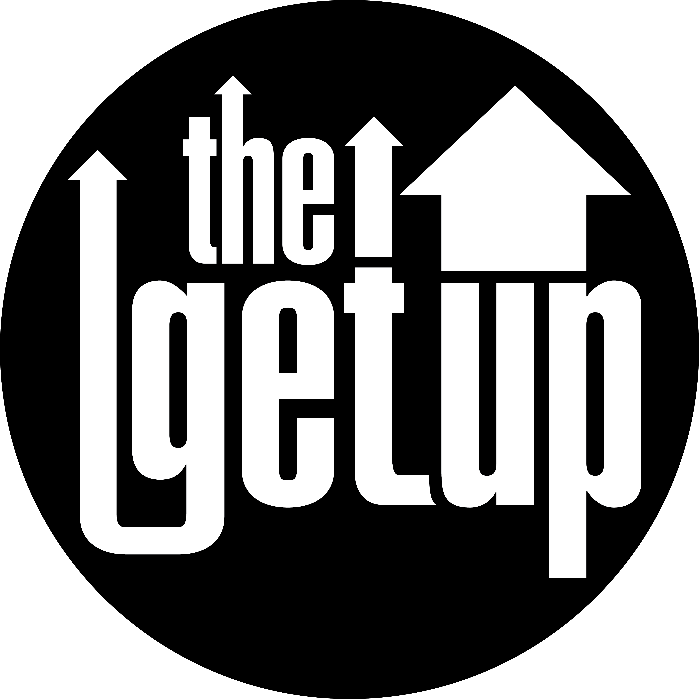

The Getup Setlist

Ooh Ooh
Bungels Twanger
Straight from the hob
Take The Cake
Do What you Wanna Do
Best Thing
Gold Digger
Moonshine
Take You Down
Diamond Cutter
Nelson Street
Got to Get it
Back To Me
Hush
Sugar mama
What If
Get Lucky

